**CITY CONNECT Bank**

**Housing Loan Processing System**

**Design Document**

**Version No1.0**

GROUP 1

ANUGU MADHU

MARAGADA VENKATESH

RITIK BHATODRA

SRIDEEP BANERJEE

TANUSHA KUTAKULA

VISHAL S K

TABLE OF CONTENTS

1.ABSTRACT

2.INTRODUCTION

* 1. PURPOSE OF THIS DOCUMENT
  2. PROJECT OVERVIEW
  3. SCOPE

## 3.CONSTRAINTS, ASSUMPTIONS AND DEPENDENCIES

# 4. PROCESS ARCHITECTURE

### 5. PROCESS FLOW DETAILS

# 6. PROCESS DEFINITIONS

7. METHODOLOGY

7.1DB2 PART VIA SPUFI

7.2COBOL PART

7.3DEFAULTER REPORT FILE

7.4JCL PART

8. FLOW DIAGRAMS

1. **ABSTRACT**

The main objective of this project is to create and maintain a CITY CONNECT Bank Loan System. The Loan processing system has various sub systems involved like Housing loan, Educational loan, Personal loan, Agricultural loan, Car loan and Business loan. This application will process the Loan request from various applicants and approve the Loans based on the eligibility criteria.

This project is about taking a note of the Late Payers and Defaulters and making a report for the back to reduce their workload by 60%.

# 2.INTRODUCTION

## 2.1 Purpose of this document

This document is aimed at

* Providing the necessary inputs to the detailed requirements gathering phase and further on for the SDLC processes.
* This document also serves to establish the traceability between the Business Objectives and the requirements identified in the proposed solution and how they satisfy the stated objectives.
* Provide expectation traceability in terms of the requirements and the user expectation
* Serves as a formal template for documenting the Business Requirements which also includes statutory and regulatory requirements.

## 2.2 Project Overview

The main objective of this project is to create and maintain a CITY CONNECT Bank Loan System. The Loan processing system has various sub systems involved like Housing loan, Educational loan, Personal loan, Agricultural loan, Car loan and Business loan. This application will process the Loan request from various applicants and approve the Loans based on the eligibility criteria.

## 2.3 Scope

### 2.3.1 In scope

The data from the loan applicants should be verified and validated. Loans should be processed for the valid records and reports should be generated out of it on yearly basis.

### 2.3.2 Out Scope

The rejected applicant data after verification will be deleted from loan database and information about those customers will be maintained in the history database inside this application.

## 3.CONSTRAINTS, ASSUMPTIONS AND DEPENDENCIES

3.1 Constraints:

* The CITY CONNECT Bank System will accept the valid customer data.
* This application will accept and process the data sent on daily basis to CITY CONNECT bank.

3.2 Assumption:

* The applicant data should be sent to the CITY CONNECT Bank System only.
* This application will process only the valid customers.
* The error data will be sent to the Customer operations and LOB (Line of Business) agents as a report.

3.3 Dependencies and Risk:

* This application should be active for all calendar days. Any outage on the external data system and third party verification system should not impact this application.
* .This application should be active even if there are no customer’s data to get processed on any calendar days.

# 4. PROCESS ARCHITECTURE

The major activities that will be involved in the housing loan system are:-

* Validate the Housing Loan request from various applicants and approve the Loans based on the eligibility criteria.
* Eliminates the customer data which are not having a valid data for CITY CONNECT Bank Loan system. Store all the rejected records which fail on the basic validation check in the Error file.
* Load the applicant and Loan data base with the housing loan details once the loan is approved by the bank.
* Pay the monthly repayment housing loan amount through collection agency recognized by CITY CONNECT Bank.
* On Daily Basis the list of housing loans for which repayment is not paid as per the due date will be identified and notification will be send to the defaulters of the loan.

The Bank will clean up the obsolete housing loan entries from its DB and store the necessary details about the obsolete loan alone in history DB for reference.

### 5. PROCESS FLOW DETAILS

The proposed application process flow is as follows:-

* For each payment posted into the payment table using Payment Detail File check whether the payment has crossed the Next Repayment Due Date in the loan Table.
  + - Get AMOUNT PAID DATE from the payment detail file compare it against the NEXT REPAYMENT DUE DATE in the loan table, if the difference in the days is less than 30 report late payments as below
* Report the below details in a daily Report file. Write the report file as CSV (Comma Separated Value) File.

1. Report Creation Date
2. Applicant ID
3. Applicant name
4. Applicant Address (Door No, Street, City, State, Pin Code)
5. Contact Number
6. Loan ID
7. Loan Type
8. Balance Amount
9. Due Date
10. Monthly Repayment Amount
    * + For defaulters more than 30 days create defaulters file

Note: Defaulters file should be the same layout as the Report File Detail Record without the header and the trailer records

* Sort the detail records in the order of Loan Type, Applicant ID and Loan Id using SORT Utility. Make sure that there is no change in header and Trailer records order.
* Take a Backup of the sorted report in in a GDG file where GDG limit is 7 versions.
* Update the Approved Loan amount in the Loan data base for the records whose repayment is not paid as per the due date as below,

Extract the details of Applicants from the defaulter file who have not made a payment for more than a month and calculate the total amount paid by the applicant against the loan. Generate a separate report file for the above applicants in the standard report format. Use page break logic. Maximum no of line to be displayed in a page is 11.

# 6. PROCESS DEFINITIONS

**Make a report out of csv and back it up into a gdg after sorting**

**Accept the Payment data**

**Split the records into who paid within 30 days as csv file and defaulter file**

Display grand total repayment amount at the end.

**Make a report of the defaulters file as well**

**7. METHODOLOGY**

**7.1 DB2 PART via SPUFI**

A. Creating Applicant and loan databases using with the following columns.

A.1. Application database (INPUT1)

**Table name: APPLICANT_DATABASE**

--> Applicant_ID CHAR(10)

--> Applicant_name VARCHAR(32)

--> Door_no CHAR(10)

--> Street CHAR(20)

--> City CHAR(20)

--> State CHAR(20)

--> PIN NUM(6)

--> Cell_phone_No. CHAR(10)

A.2. Application loan details database (INPUT2)

**Table name: LOAN_DATABASE**

--> Loan Id NUM(2)

--> Loan amount INTEGER S9(9)

--> Loan approval date DATE(10)

--> Expected loan closure date DATE(10)

--> Balance amount DEC(9,2) S9(7)V99

--> Next due date DATE(10)

--> Total repayment amount INTEGER S9(9)

**7.2 COBOL PART**

USING 3 INPUTS WE PERFORM A SET OF OPERATIONS AND GET THE DESIRED RESULT BY THE PROCESSES MENTIONED BELOW.

7.2.1CURSOR

7.2.2. EVALUATING THE DIFFERENCE OF THE DATE

1. EVALUATE TRUE

WHEN WS-DIFF-DATE <= 30

PERFORM 0006-REPORT-WRITE-PARA THRU

0006-REPORT-WRITE-PARA-EXIT

[ WHEN THE DATE DIFFERENCE IS LESS THAN OR EQUAL TO 30 DAYS THEN WE CREATE THE REPORT AS A CSV FILE ]

2. WHEN WS-DIFF-DATE > 30

COMPUTE WS-TOTAL = LO-TOTAL-REPAYMENT-AMOUNT - LO-BALANCE-AMOUNT

PERFORM 0007-DEFAULTER-WRITE-PARA THRU

0007-DEFAULTER-WRITE-PARA-EXIT

[ WHEN THE DATE DIFFERENCE IS MORE THAN 30 DAYS THEN WE CREATE THE

DEFAULTER FILE ]

3. WHEN OTHER

DISPLAY 'INCOMPATIBLE VALUE '

END-EVALUATE.

[FOR OTHERS JUST DISPLAY AN ERROR MESSAGE]

7.3DEFAULTER REPORT FILE

1. OPENING THE DEFAULTER FILE (INPUT)AND REPORT FILE(OUTPUT)
2. READING BOTH INPUT AND OUTPUT FILE
3. MOVING THE HEADERS
4. MOVING THE RECORDS( MULTIPLE OF 11)

1. MOVING THE TRAILER(EOP)
2. DISPLAYING SUM OF TOTAL MONTHLY REPAYMENT

7.4 JCL PART

FIRSTLY, WE TAKE THE CSV FILE AS INPUT AND WITH SORT UTILITY WE SORT THE FIELDS

IN A TEMPORARY DATASET WE LOAD THE CSV FILE AFTER SORTING.

THEN WE TAKE A BACKUP OF IT IN A GDG WITH 7 GENERATIONS.

8.FLOW DIAGRAMS

8.1 COBOL-DB2 PROGRAM LAYOUT

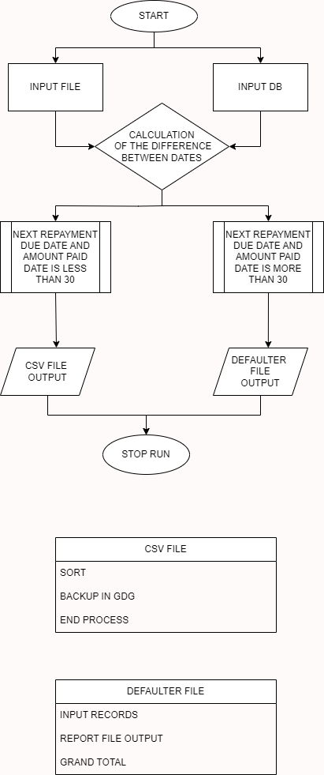

8.2 JCL PROGRAM LAYOUT

8.3 REPORT PROGRAM LAYOUT

